Step 1: Open the terminal with a command

**press Ctrl, Alt and T keys**

Step 2: Open a vi editor from the terminal

Step 3: Create a file file.txt with paragraph of sample text (explaining why is devops required in your own words)

Step 4: Save the File

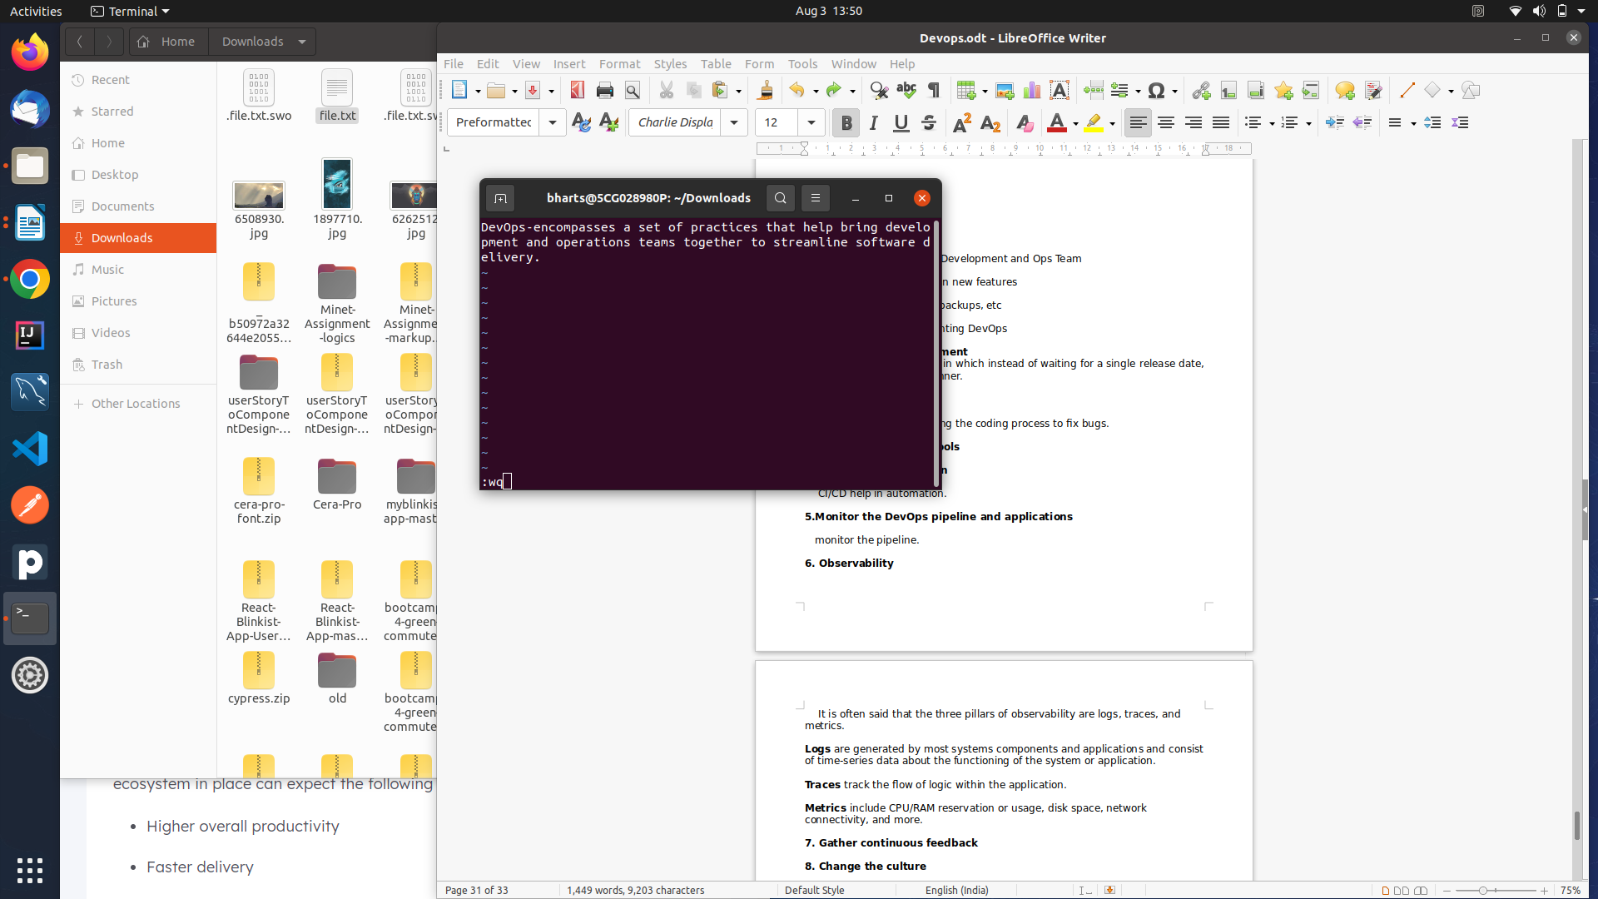

Step 5: Using a command, change the case(upper to lower, lower to upper) of words

**:[range]s[ubstitute]/{pattern}/{string}/[flags] [count]**

**:%s/.*/\L&/**

**-%s –** specifies all lines.

**:%s/.*/\U&/**

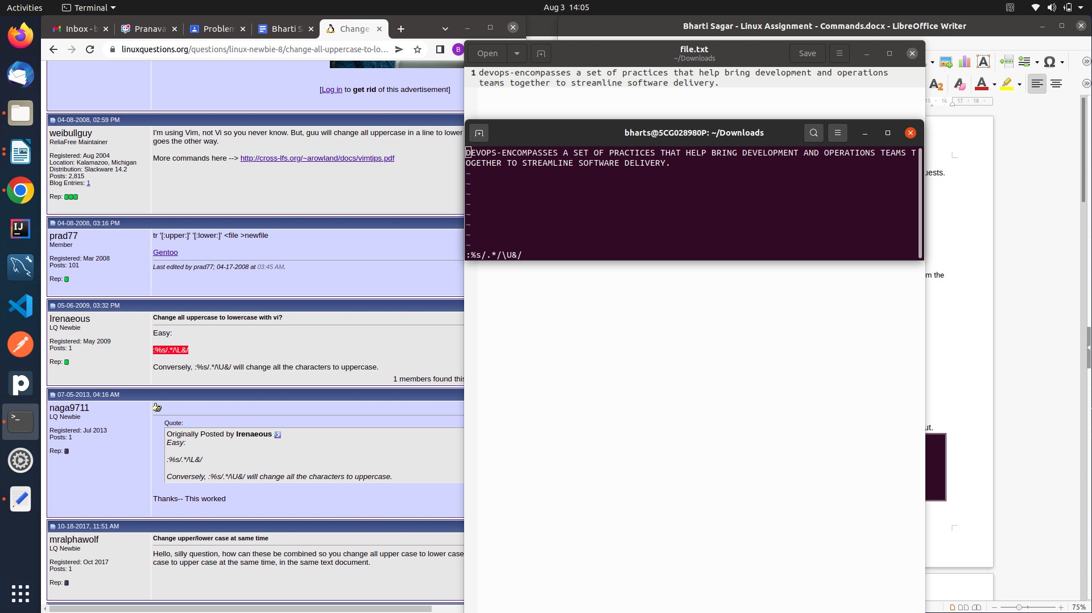

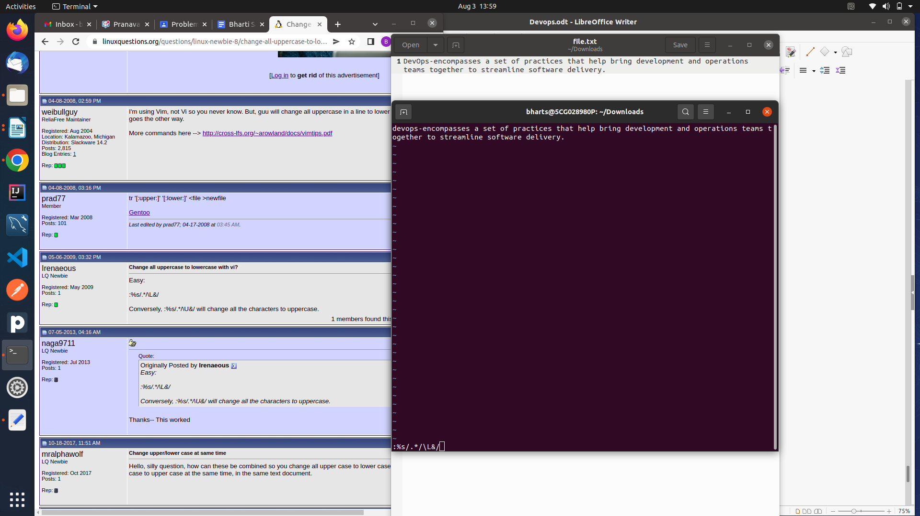

Step 6: Using a command, replace matching words "devops" with your name

**:%s/DEVOPS/bharti/g**

